**Worksheet – 1.1**

**Student Name: Ankit Kumar UID: 21MCA2139**

**Branch: MCA Section/Group: 7A**

**Semester: 3rd Date of Performance: 18-09-2022**

**Subject Name: Machine Learning LAB Subject Code: 21CAP-703**

1. **Aim/Overview of the practical:**

Write a program that will predict the medical insurance cost.

1. **Task to be done:**

predict the medical insurance cost.

1. **Code for experiment/practical:**

import pandas as pd

insurance = pd.read_csv("insurance.csv")

insurance.head()

insurance[['sex','smoker','region']].head()

# Replacing string values to numbers

insurance['sex'] = insurance['sex'].apply({'male':0, 'female':1}.get)

insurance['smoker'] = insurance['smoker'].apply({'yes':1, 'no':0}.get)

insurance['region'] = insurance['region'].apply({'southwest':1, 'southeast':2, 'northwest':3, 'northeast':4}.get)

insurance.head()

import seaborn as sns

# Correlation betweeen 'charges' and 'age'

sns.jointplot(x=insurance['age'],y=insurance['charges'])

import seaborn as sns

# Correlation betweeen 'charges' and 'age'

sns.jointplot(x=insurance['age'],y=insurance['charges'])

# features

X = insurance[['age', 'sex', 'bmi', 'children','smoker','region']]

# predicted variable

y = insurance['charges']

# importing train_test_split model

from sklearn.model_selection import train_test_split

# splitting train and test data

X_train, X_test, y_train, y_test = train_test_split(X, y, test_size=0.4)

len(X_test) # 402

len(X_train) # 936

len(insurance) # 1338

# importing the model

from sklearn.linear_model import LinearRegression

model = LinearRegression()

# Fit linear model by passing training dataset

model.fit(X_train,y_train)

# Predicting the target variable for test datset

predictions = model.predict(X_test)

predictions[0:5]

import matplotlib.pyplot as plt

plt.scatter(y_test,predictions)

plt.xlabel('Y Test')

plt.ylabel('Predicted Y')

# Predict charges for new customer : Name- Frank

data = {'age' : 40,

'sex' : 1,

'bmi' : 45.50,

'children' : 4,

'smoker' : 1,

'region' : 3}

index = [1]

frank_df = pd.DataFrame(data,index)

frank_df

prediction_frank = model.predict(frank_df)

print("Medical Insurance cost for Frank is : ",prediction_frank)

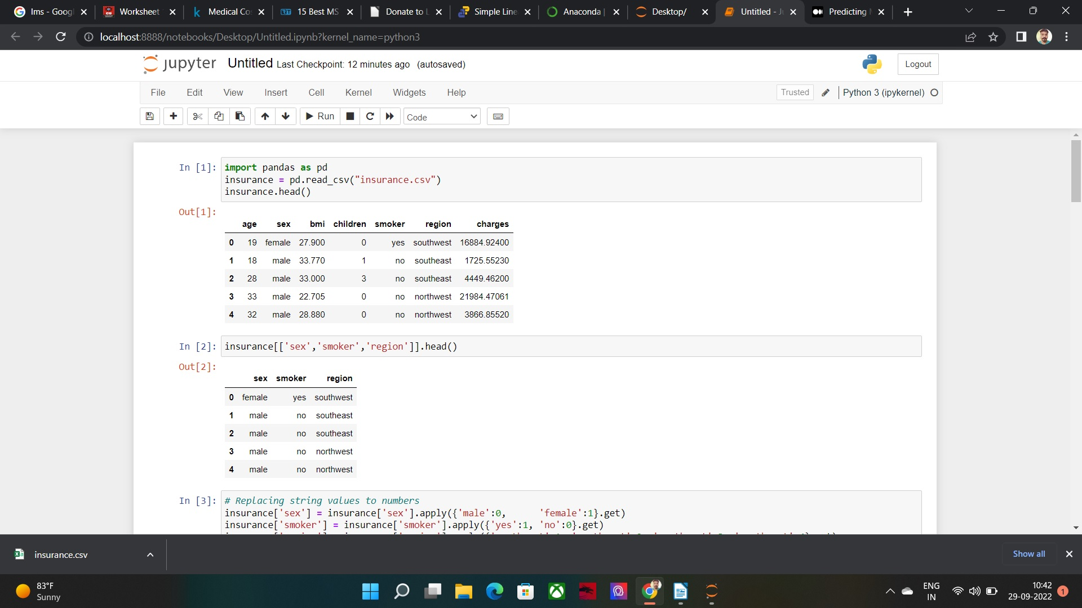

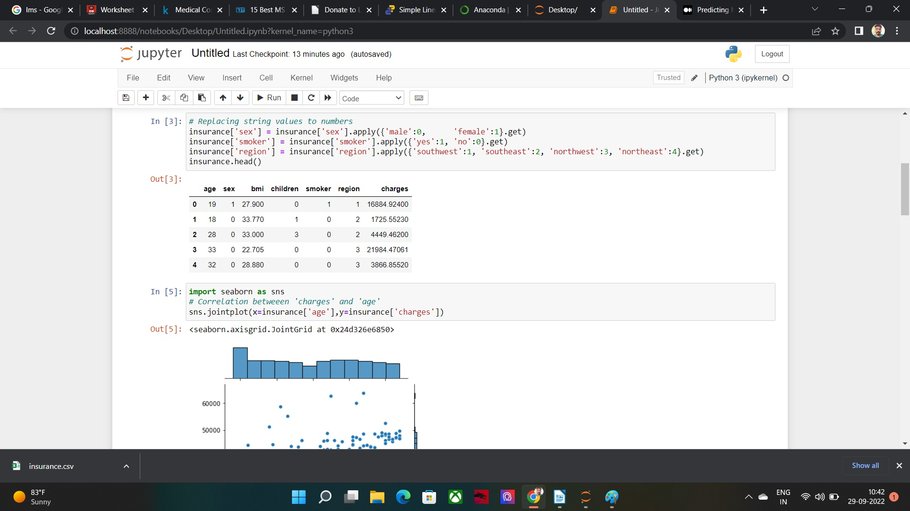

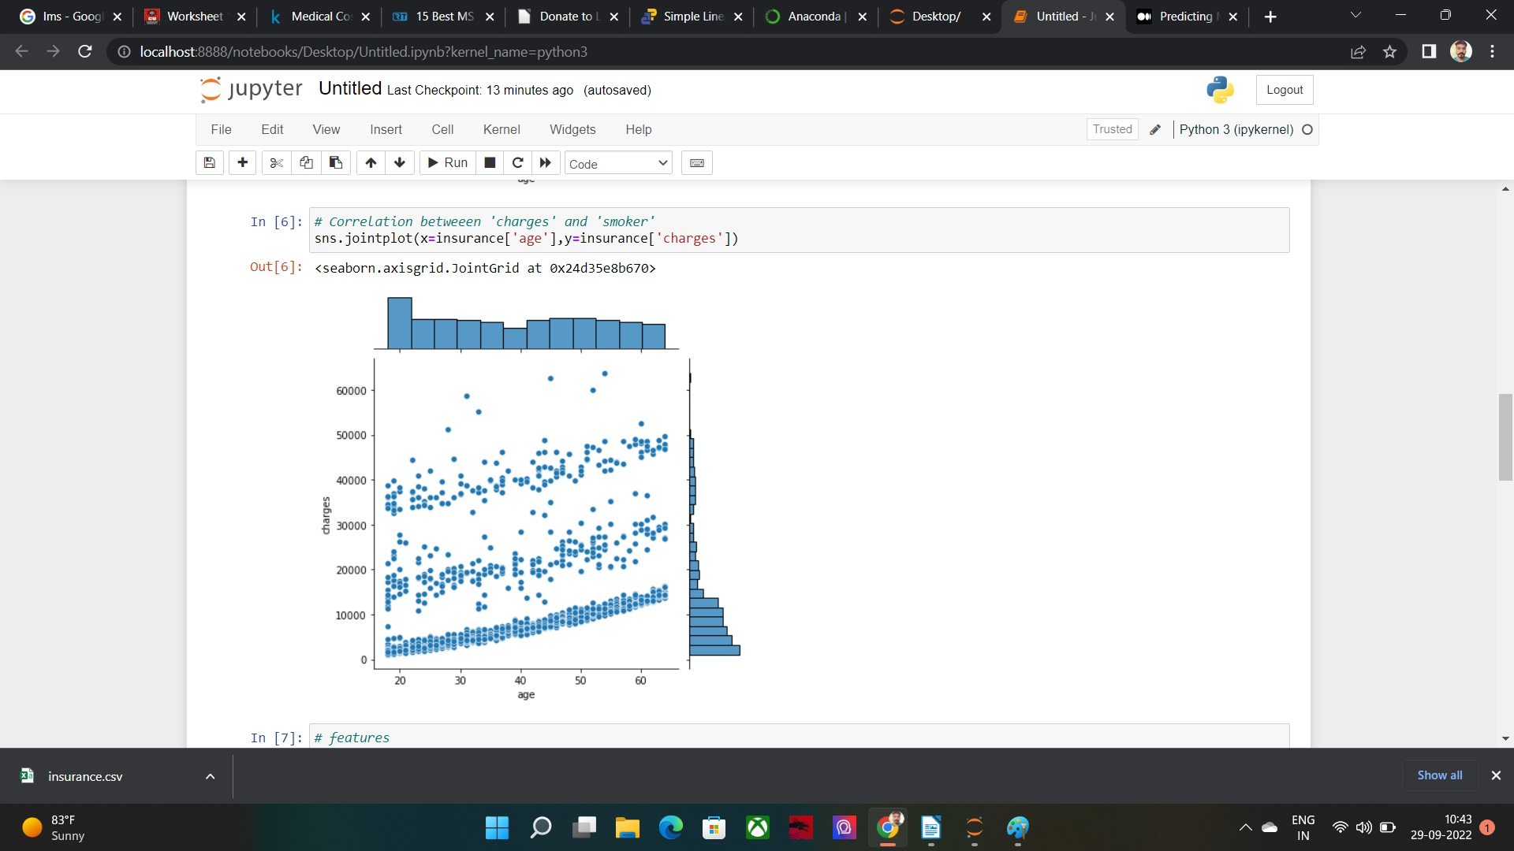

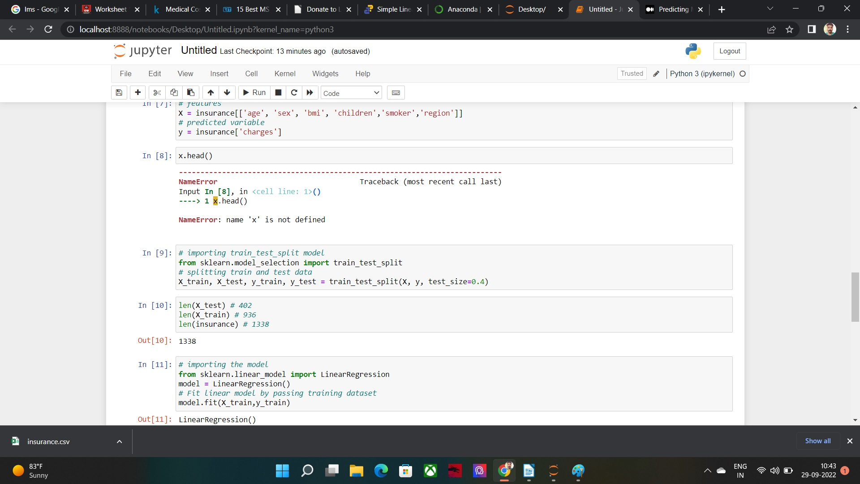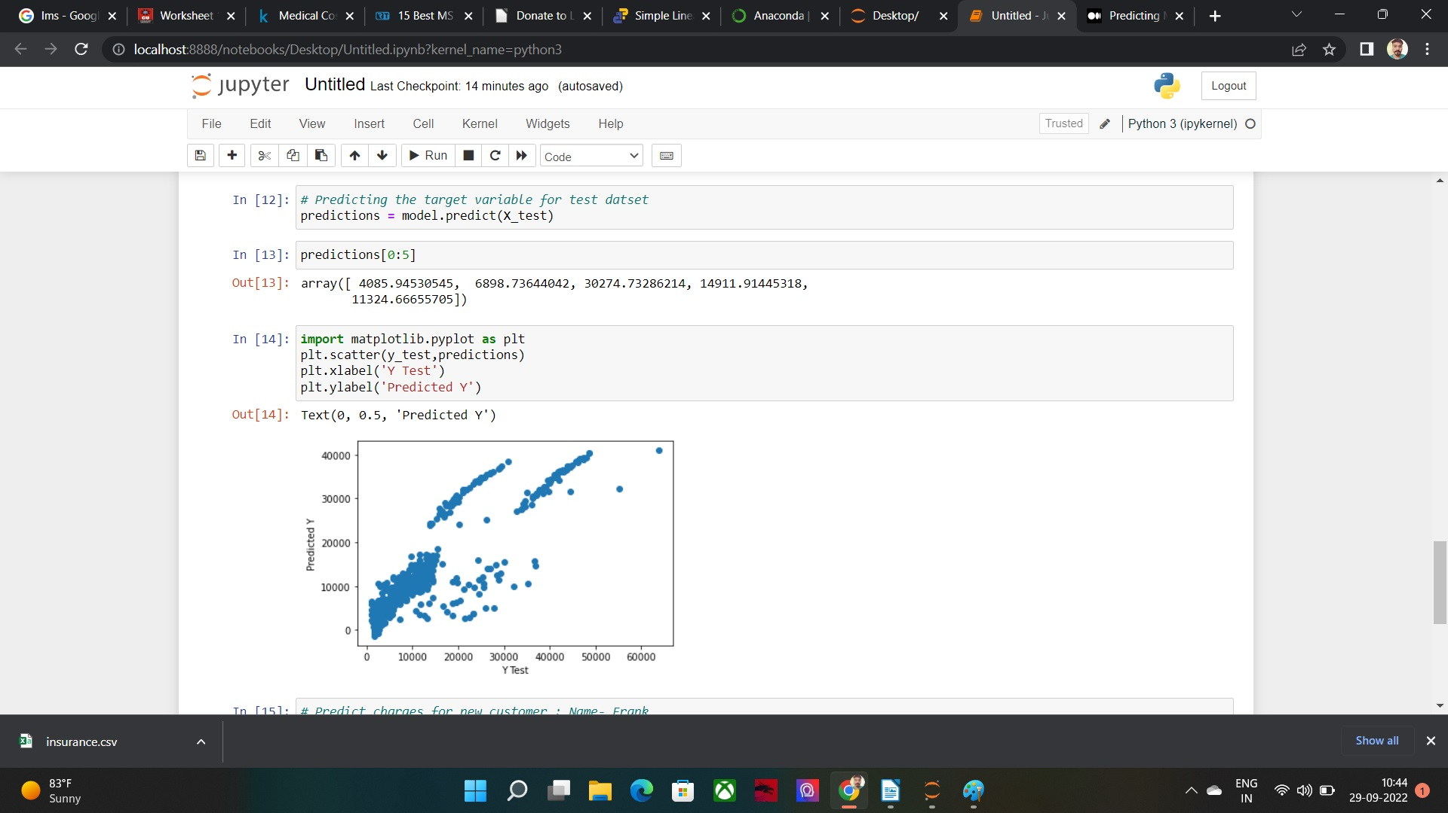

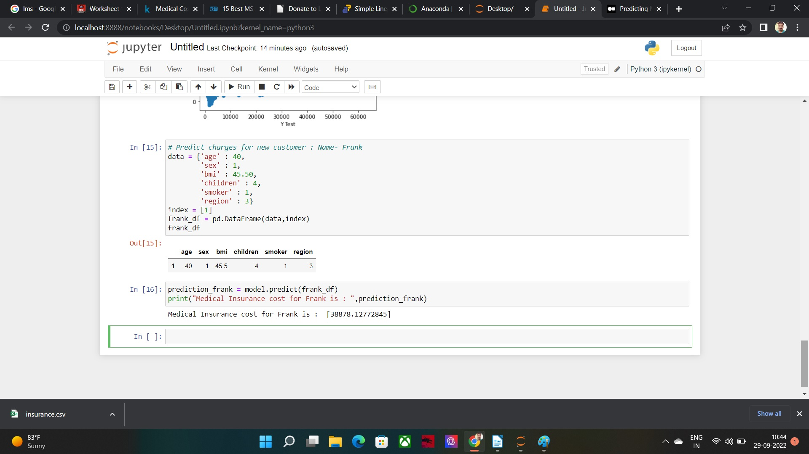

**Learning outcomes (What I have learnt):**

**2.** Also got familiar with the real-life use of machine learning.

**Evaluation Grid:**

|  |  |  |  |
| --- | --- | --- | --- |
| Sr. No. | Parameters | Marks Obtained | Maximum Marks |
| 1. | Demonstration and Performance |  | 5 |
| 2. | Worksheet |  | 10 |
| 3. | Post Lab Quiz |  | 5 |